CARE – Secure Web Config with Environment Variables

Environment Variables
https://www.alphr.com/set-environment-variables-windows-11/

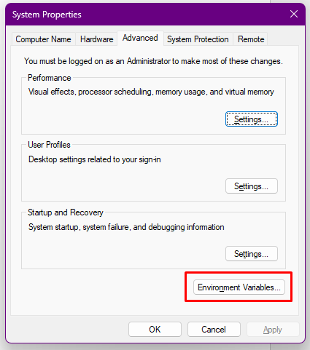

Update Code
WebUtility.vb -> function GetAppSetting

Public Function GetAppSetting(ByVal AppSettingID As String) As String
Dim value As String
value = WebConfigurationManager.AppSettings(AppSettingID)
If value Is Nothing Then
value = Environment.GetEnvironmentVariable(AppSettingID, EnvironmentVariableTarget.Machine)
End If
Return value
End Function

Implementation
Create Environment Variables keys based on existing keys in web.config that are considered important and need protection.Such as SMTP authentication, API key and others.
Example
- Go to Environment Variables
- Navigate to System Variables -> New
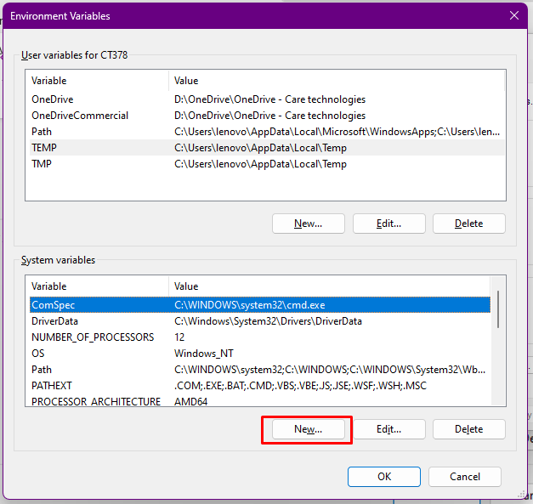
- Fill the Varible Name and Value
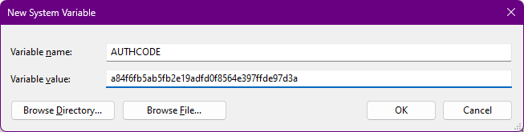
- Click OK
- Remove Key in Web.config that have been migrated to Environment Variables
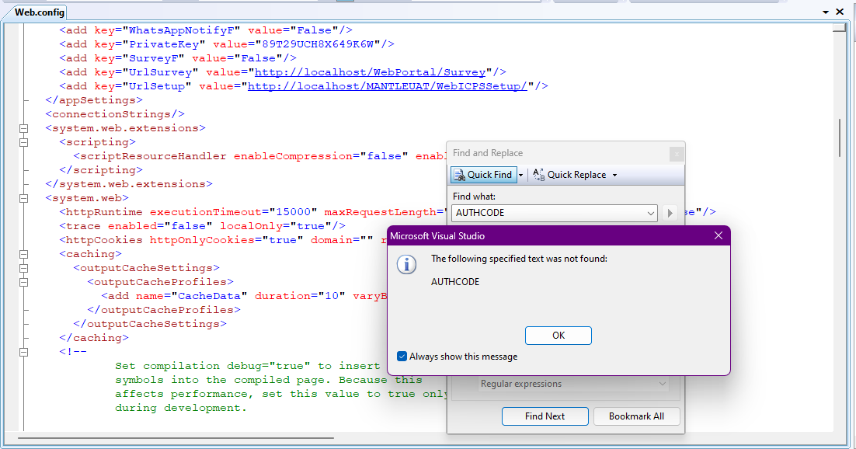

Proof
